Linksys Port Forwarding

This chapter will cover a few simple configurations for the Linksys router. Please understand we do not support this product and will not give tech support on it. If you need Technical support on this router you must call Linksys. This Chapter is to offer some help to the installer and end user nothing more.

To access the Web-based Utility, launch Internet Explorer or Netscape Navigator, and enter the Router’s default IP address, 192.168.1.1, in the Address field. Then, press Enter. A password request page will appear. (Non-Windows XP users will see a similar screen.) Leave the User Name field blank. The first time you open the Web-based Utility, use the default password admin. (You can set a new password from the Administration tab’s Management screen.) Click the OK button to continue.

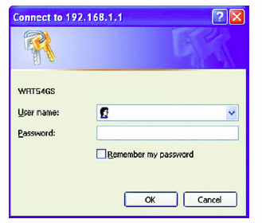

The first screen that appears displays the Setup tab. This allows you to change the Router's general settings. Change these settings as described here and click the Save Settings button to apply your changes or Cancel Changes to cancel your changes.

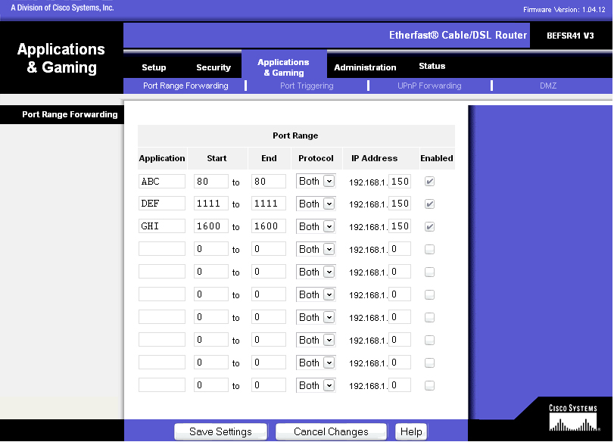

The Applications and Gaming Tab allows you to set up public services on your network, such as web servers, ftp servers, e-mail servers, or other specialized Internet applications. (Specialized Internet applications are any applications that use Internet access to perform functions such as videoconferencing or online gaming. Some Internet applications may not require any forwarding.)

To forward a port, enter the information on each line for the criteria required. Descriptions of each criteria are described here.

Application - In this field, enter the name you wish to give the application. Each name can be up to 12 characters.

Start/End - This is the port range. Enter the number that starts the port range under Start and the number that ends the range under End.

Protocol - Enter the protocol used for this application, either TCP or UDP, or Both.

IP Address - For each application, enter the IP Address of the PC running the specific application.

Enable - Click the Enable checkbox to enable port forwarding for the relevant application.

Change these settings as described here and click the Save Settings button to apply your changes or Cancel Changes to cancel your changes.

Example:

DVR 80 to 80 Both 192.168.1.50 Enable

DVR 1600 to 1600 Both 192.168.1.50 Enable

DVR 37260 to 37260 Both 192.168.1.50 Enable

  - Note: If your Internet service provider blocks port 80 and you are using a different port to access the DVR through the DVR’s Network Menu Setup please open those specific ports in this section of the router.

The following is the address you would type:

http:// IP address of your internet service provider: 8100

Dynamic DNS

The Router offers a Dynamic Domain Name System (DDNS) feature. DDNS lets you assign a fixed host and domain name to a dynamic Internet IP address. It is useful when you are hosting your own website, FTP server, or other server behind the Router. Before you can use this feature, you need to sign up for DDNS service at
www.dyndns.org, DDNS service providers.

DDNS Service - From this pull-down menu, enter the DDNS service with which you have membership.

User Name - Enter the User Name for your DDNS account.

Password - Enter the Password for your DDNS account.

Host Name - There is the DDNS URL assigned by the DDNS service.

Internet IP Address - This is the Router’s current IP Address as seen on the Internet.

Status - This displays the status of the DDNS connection.

Change these settings as described here and click the Save Settings button to apply your changes or Cancel Changes to cancel your changes.

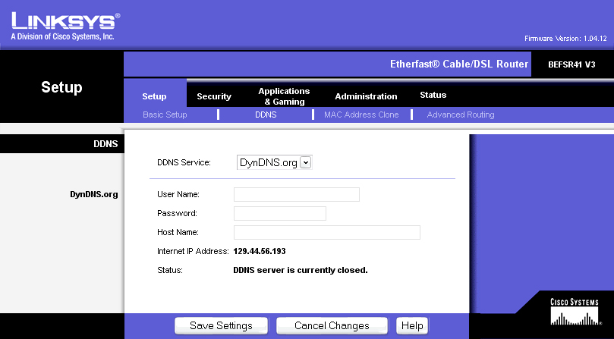

D-Link Port Forwarding
This chapter will cover a few simple configurations for the D-Link router. Please understand we do not support this product and will not give tech support on it. If you need Technical support on this router you must call D-Link. This Chapter is to offer some help to the installer and end user nothing more.

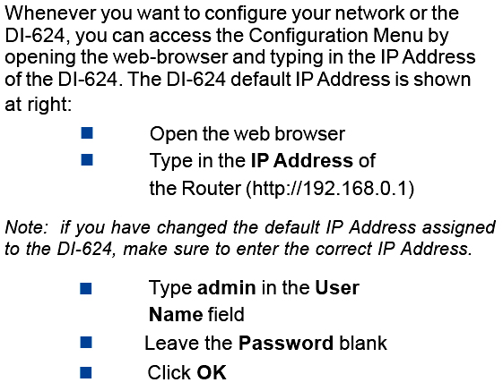

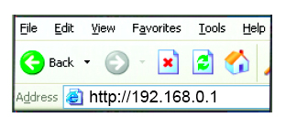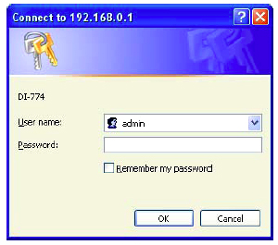
- The next step is to open ports within your router. Go to Virtual Server in the router.

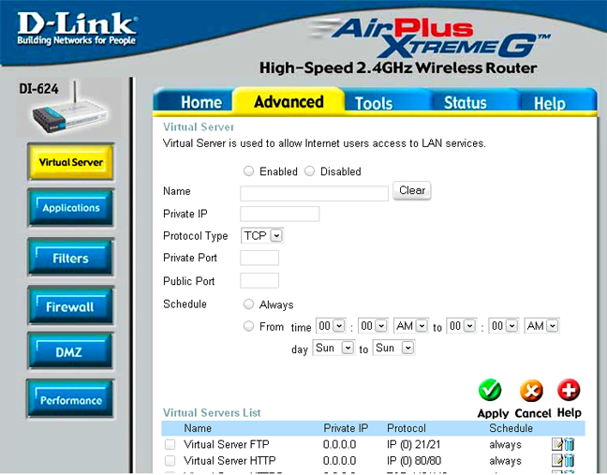

Example1:

Protocol Type - The protocol used for the virtual service.

Public Port - The port number on the WAN (Wide Area Network) side that will be used to access the virtual service.

Private Port - The port number of the service used by the Private IP computer.

Schedule - The schedule of time when the virtual service will be enabled.
The schedule may be set to Always, which will allow the particular service to always be enabled. If it is set to Time, select the time frame for the service to be enabled. If the system time is outside of the scheduled time, the service will be disabled.

Virtual Server - Select Enabled or Disabled

Name - Enter the name referencing the virtual service
Private IP - The server computer in the LAN (Local Area Network) that will be providing the virtual services. If you have a Web server that you wanted Internet users to access at all times, you would need to enable it. Web (HTTP) server is on LAN (Local Area Network) computer

192.168.0.50 HTTP uses port 80, TCP and UDP.

Name: DVR
Private IP: 192.168.0.50
Protocol Type: Both
Private Port: 80
Public Port: 80
Schedule: always

- The next step is to open ports within your router. Open virtual ports in the router.

  - Ports to open: 80, 1600, 37260, 37261, 37262, 37263

  - Note: If your Internet service provider blocks port 80 and you are using a different port to access the DVR through the DVR’s Network Menu Setup please open those specific ports in this section of the router.

- If your Internet Service Provider Blocks port 80. Simply do the following:

  - Change the HTTP port from 80 to 8100 in the NETWORK MENU.

- To access the DVR from a computer simply open Internet Explorer and in the address bar type:

The following is the address you would type:

http:// IP address of your internet service provider: 8100

Dynamic DNS

Dynamic Domain Name System is a method of keeping a domain name linked to a changing IP Address. This is a useful feature since many computers do not use a static IP address.

- To setup Dynamic DNS simple go to Tools and the Misc. At the bottom of the screen you will be able to enable DynDNS.

- Once you have enabled it enter the server address of DynDNS.org:
members.dyndns.org

- Then enter the hostname you created with DynDNS.org
Example: Everfocus.homeip.net

- Then enter the username and password you use to log into DynDNS.org

